STRSAD.RPT

Employee Name:

USPSCN/BIOSCN, Name fields.

Soc-Sec-Num:

USPSCN/BIOSCN, SSN field.

3. Credit:

Employees flagged as full-time must have at least 120 service days to be granted a full year of service credit toward retirement. For employees flagged as full-time and did not work 120 days, or is considered part-time, the service credit is calculated as follows:

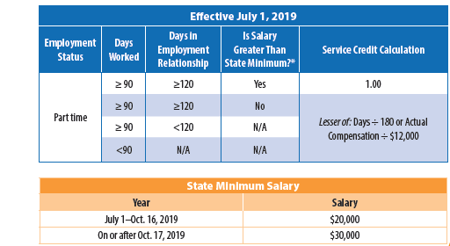

NOTES:

**Employment relationship = Compares the academic dates entered in STRSAD to
the Hire date on the BIOSCN record. It will take this date or July 1, of the
the reporting year as the starting date (whichever is later) and calculate the
days from that day to the Termination date on BIOSCN or June 30 (whichever is
earlier).

** The relationship of the employee with the district is based on “ALL” days in the calendars minus weekend days

**State minimum = $30,000.00

**The employee termination date on BIOSCN must be updated when an employee leaves the district. This field should not be confused with the termination date on JOBSCN. STRSAD checks the BIOSCN termination date when determining employment relationship.

4. STRS Days:

The system first finds all the checks for employees, which have a pay date in the fiscal year. The payroll beginning and ending dates for those checks determine the calendar date range for counting service days. This range (very likely) will start in the preceding fiscal year and end during the current fiscal year. From this information, blank working calendars are created on the system. Blank working calendars are used internally by the system and can not be viewed.

The jobs calendars from the employee’s fiscal years payroll are entered into the blank working calendars. The ATDSCN transaction types AT or AB with paid dates in the reporting period are marked on the working calendars appropriately for each day. The calendars are ‘modified’ inside the program to reflect the days from the calendars plus days from the ATDSCN. Duplicate dates are not counted twice. So you can think of ATDSCN records as modifying the calendars on a per employee basis.

The system then locates any adjustment transactions (AD) for the fiscal year for STRS. Adjustment transactions entered through ATDSCN are considered manual adjustments to what the system would calculate. Note that ‘manual adjustment’ transactions are picked up based on the fiscal year instead of the date range that the employee was paid for. Any adjustment dated within the reporting period will be applied. The manual adjustment records are a bit different because they are not for specific days. The adjustments (if any) are added to or subtracted from the total unadjusted service days and that total is the total that will appear on the STRSAD report.

The days are not reported to STRS, only the percentage of credit.

5. Earnings:

Calculated by taking the FYTD gross amounts from the 450 record PLUS the amounts earned but not yet paid to the employee.

Advanced earnings are calculated as follows:

Obligation Pay per Period
-Amt. Paid AND X Remaining Number of Pays
-Dock -------------------------------------
-------------- Remaining to Pay Based on Pay/Period Obligation
Remaining to Pay

NOTE:

**This can be inflated if an employee has 691 deduction record and fringe benefit extra
compensation.

The earnings are not reported to STRS.

6. Deposit/Pick UP:

FYTD total deducted amount listed on the 450, 591 and 691 deduction records.
This amount does not include contributions on amounts earned but not yet paid.

7. Advanced Amount:

Calculates retirement amount on summer pays on a per pay basis per job as follows:

Pays Remaining | Pay Per Period | Retirement Withheld
23 | $1504.00 | $210.56
24 | $1504.00 | $210.56
25 | $1504.00 | $210.56
26 | $1500.00 | $210.00
Total | $6012.00 | $841.68

8. Total Taxed + Non-Taxed:

Amount deposited with STRS during fiscal year PLUS amount of contributions on earnings that have not yet been paid. This amount can be inflated if there are 691 (board pickup) records.

